**Transient Search Automation Application**

**Overview**

Transient Search is a Windows 10 application whose purpose is to automate the query, results translation and reconfiguration for the input of four specialized astronomical catalogs as SDB’s (Sky Database) in the TheSkyX™ platform. The four servers are:

1. IAU Transient Name Server (TNS) is the official IAU mechanism for reporting new astronomical transients such as supernova candidates.
2. AAVSO International Variable Star Index (VSX) for current listings of galactic nova, BL Lac, AGN, Quasar, and currently reported, but unconfirmed, variable star candidates.
3. NASA ExoPlanet Archive for the current listing of active ExoPlanet candidates.
4. IAU Minor Planet Center Ephemeris for the current listing of positions for all Near Earth Objects (NEO).

Transient Search can perform queries of each of these servers then compile the results in a form the TheSkyX can import as either in the clipboard or text file to make a My Chart Elements listing or import into a user Sky Database using Create Sky Database functionality. The all resultant custom catalogs will contain at least the object name, type, location (ra,dec) and magnitude. Other data fields may also be translated depending upon the server and the Transient Search version.

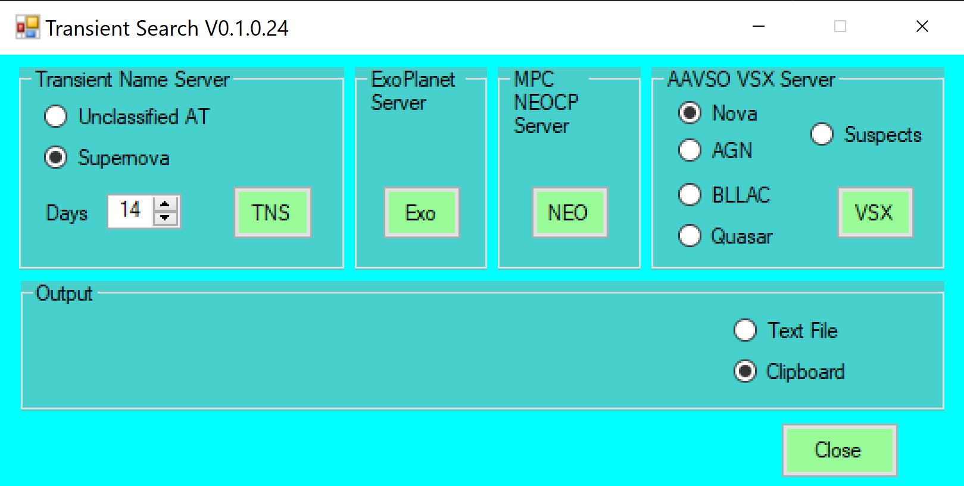**Description**

A single button initiates query and translation of results from each of the servers. For the TNS and VSX servers a couple of criteria can be set. The other queries are fixed.

For the TNS server, the user can select either a list of confirmed supernova only, or a full list of all objects, confirmed and unconfirmed. For TNS, the user can also define how far back (in days) that the query should look for reports.

The ExoPlanet server query returns a listing of all confirmed exo planets.

The MPC NEOCP returns a listing of all known Near Earth Objects from the Minor Planet Center catalog. These objects may be confirmed or in need of further observations.

For the VSX server, the user can select queries specific to objects listed as nova, AGN, BLLAC or Quasar. In addition, selecting “Suspects” returns a listing of all objects in need of follow up light curve measurements to verify as variable stars or other such objects.

For output, the user can select either to format the catalog for import to a Sky Database in either the clipboard or a user created file. The user should select Text File if the intention is to compile a Sky Database from the listing.

**Import to TheSkyX (or TheSky64)**

My Chart Elements: A set chart elements based on the transient catalog can be easily produced. Upon launch of TheSkyX, select the *Input* menu and choose *My Chart Elements* from the drop-down menu. In the *My Chart Elements* pop-up window, check *Show My Chart Elements* and select the *Export/Import* tab. Under *Import Chart Elements from Text*, pick either *From File* or *From Clipboard* depending on what output was selected from Transient Search. These chart elements will be displayed and persist between launches of TheSkyX, but are not usable for *Find* or *Observing List* functions.

Short-Term Sky Database: A temporary catalog which will be discarded upon closing the TheSkyX application can be created very simply. Upon launch of TheSkyX, select *Edit*, then *Paste* *Photo*. The catalog will be available for various display, find and observing list functions during that session. These cataloged objects will be displayed and usable for *Find* and Observing *List* functions, but, upon closing TheSkyX, this catalog will be discarded.

Long-Term Sky Database: An SDB which will persist between TheSkyX launches is created using the *Create Sky Database* function. However, a text file output must be created for this operation. It is not a requirement, but it is recommended that this SDB text file be created in the *SoftwareBisque/../SDBs* directory for convenience. Once Transient Search has created a SDB text file, select the *Input* menu and *Create Sky Database* from the drop-down menus. Select the *Define Fields* tab, press *Choose* for Source text file and browse to the SDB text file to be compiled. Then select the *Compile* tab. Press *Create SDB from Text File* to complete the creation a SDB.

To remove an SDB, simply delete the respective *.SDBX file which was created by the *Create Sky Database* compilation.

**Internal Operation (for source code consumers)**

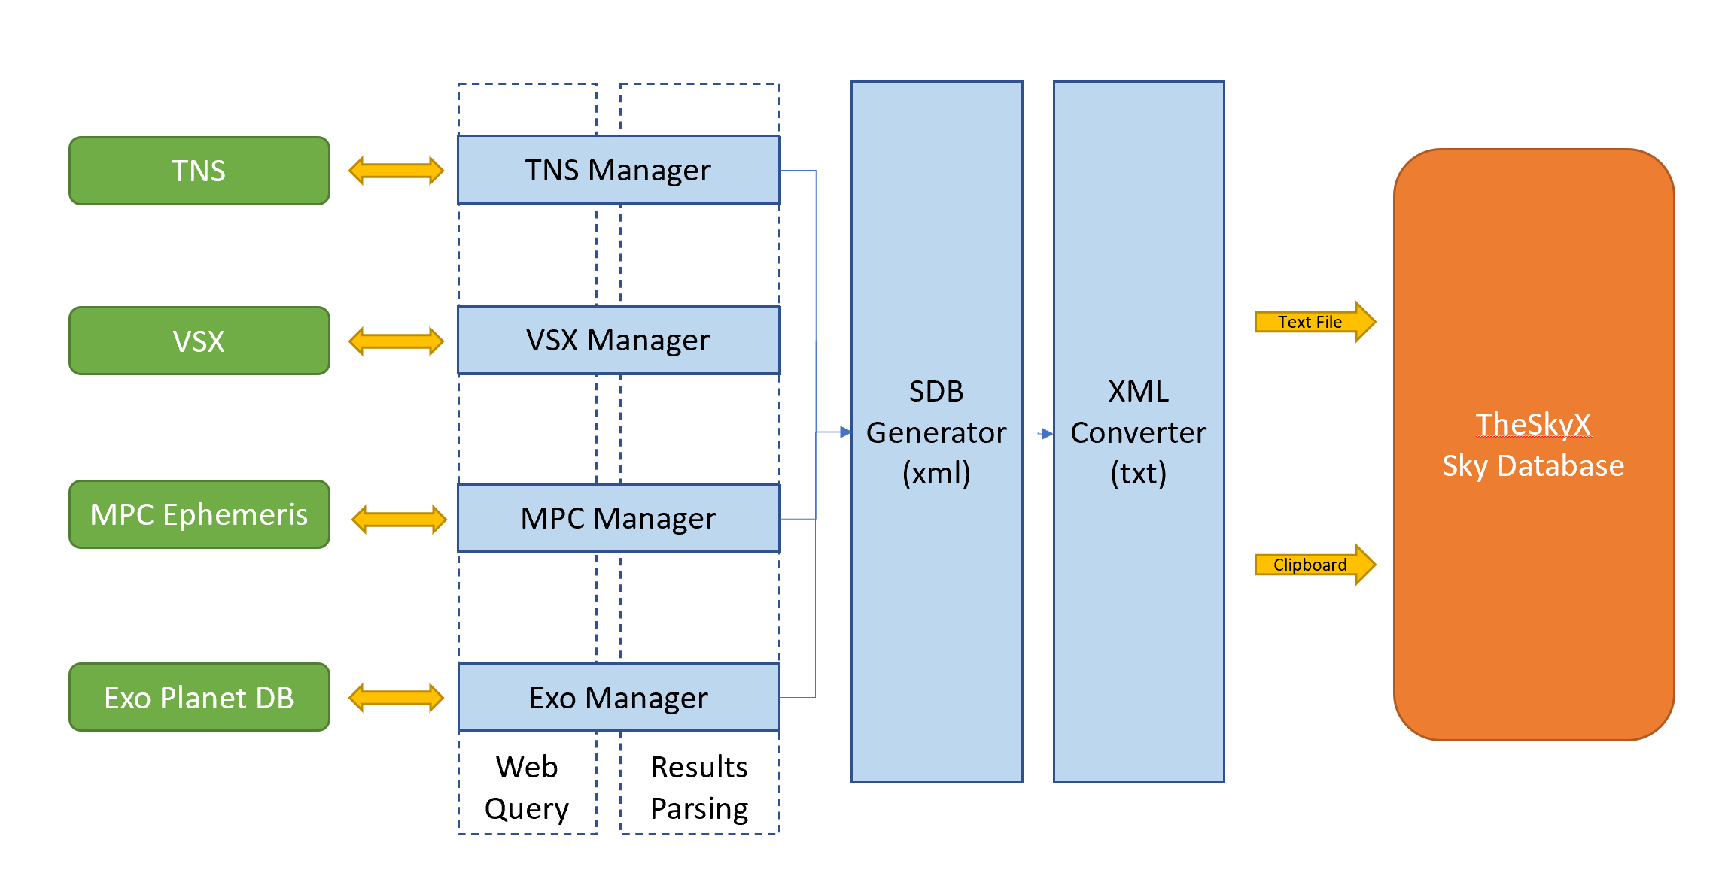

The diagram above shows the operational structure of the Transient Search app and its external dependencies. Queries to each server is managed through a separate module, although all modules share a common internal architecture. Each module consists of a method for the web query and a method for parsing the results, both managed by a common core. The output of the results parsing is a common internal xml data structure. That xml data is translated into the import text file format required by TheSkyX to create either My Chart Elements or a Sky Database which is a nonstandard combination of xml and columnar text formatting. That reformatted data is written either to the clipboard or a user-defined text file from which it can be imported to TheSkyX.

**Requirements**

Transient Search is a Windows Forms executable, written in Visual C#. The app requires TheSkyX Professional (Build 10966 or later) with the TSX Camera Add-On option. The application runs as an uncertified, standalone application under Windows 10 (also Win 8, maybe).

**Installation**

As of this writing, the installation packages for Transient Search are available on GitHub in the “publish” directory of rrskybox/TransientServer.

Download the TransientSearch.zip and extract. Run "setup.exe". Upon completion, an application icon will have been added to the start menu under "TSXToolKit" with the name "Transient Search". This application can be pinned to the Start if desired.

**Support**

This application was written for the public domain and as such is unsupported. The developer would happily entertain questions or suggestion and may update the application occasionally as time permits. Otherwise, the developer wishes you his best and hopes everything works out but recommends learning Visual C# (it's not hard and the tools are free from Microsoft) if you find a problem or want to add features. The source is supplied as a Visual Studio 2019 project on GitHub